**Permissions cheatsheet**

**Introduction**

Data analysts work with a wealth of data from diverse markets. This data must be handled with care and only accessed by authorized personnel. Power BI uses granular dataset permissions to secure and optimize data access.

In this reading, you’ll explore Power BI service’s dataset permissions and each permission level's role in safeguarding, managing, and optimizing data.

**Core dataset permissions**

Managing, protecting, and providing access to the right data is important. Power BI Service's permissions streamline data access, supporting data-driven decisions by ensuring the right data is in the right hands when needed.

Power BI’s core dataset permissions include:

* Read
* Build
* Reshare
* Write

And closely related to these permissions is the Owner role. Let’s explore these in more detail and understand how they work in Power BI.

**Read permission**

The **Read** permission allows users to access reports and other solutions that read data from the dataset. Users with this permission can view dataset settings.

Adventure Works can assign **Read** permission to members of the marketing team accessing its sales reports. The team can then analyze the raw data without making changes to it.

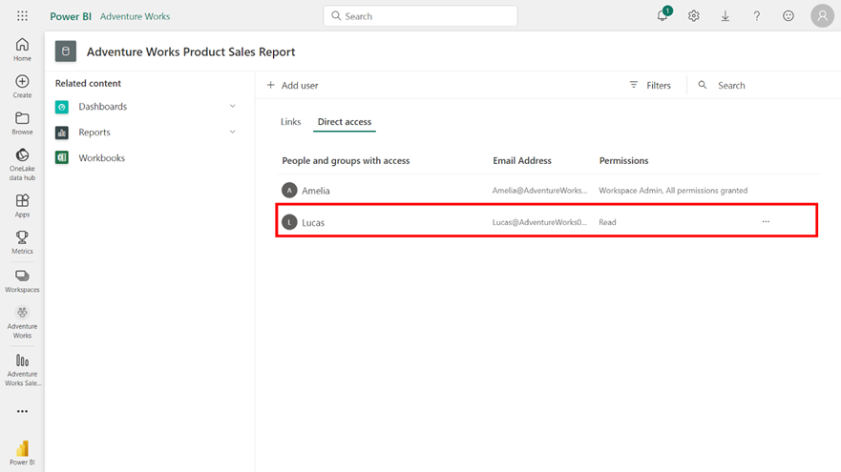

**Build permission**

Users with the **Build** permission can create new content from the dataset and find content that uses the dataset. It allows access to reports that incorporate composite models on Power BI Pro workspaces and the development of composite models.

Adventure Works needs you to use a new marketing dataset to generate new insights into the campaign's effect on bicycle sales. By ensuring you’re assigned **Build** permission, you can design visuals and gather insights from the report’s data.

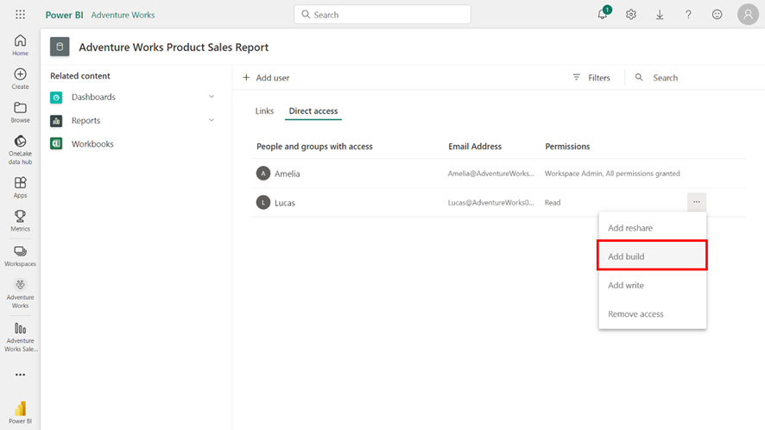

**Reshare permission**

Users with **Reshare** permission can create new content from the dataset and find content that uses the dataset. It allows access to reports that incorporate composite models on Power BI Pro workspaces and the development of composite models.

Adventure Works is developing a marketing campaign for its new range of BMX bikes. You must share your research for this project with the marketing and logistics teams. Assigning the **Reshare** permission to your reports means you can distribute data effectively, facilitating its use where it's needed rather than being a data gatekeeper.

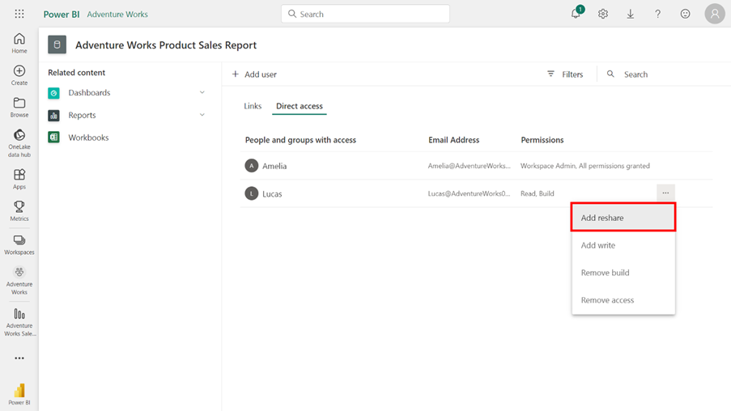

**Write permission**

The **Write** permission empowers users to republish, backup, and restore the dataset and make changes. Users with **Write** permission can edit dataset settings, but they can’t perform data refresh, credentials, and automatic aggregations.

For Adventure Works data analysts, the **Write** permission is both a feature and a responsibility. It enables you to correct data errors, like anomalies in road bike sales, ensure the accuracy of data-driven business decisions, and assure Adventure Works that the data remains impeccable under your care.

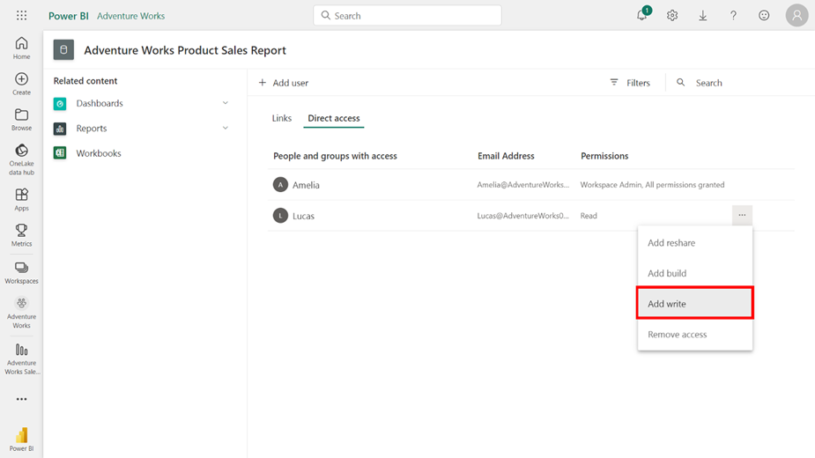

**Owner role**

The **Owner** role, while not a permission, is a comprehensive role combining all permissions and is initially assigned to the dataset’s creator. The **Owner** can configure dataset refresh, credentials, and automatic aggregations and perform all the actions other permissions allow.

You’re the owner of Adventure Works’ new marketing campaign dataset. You are pivotal in maintaining and directing the data to support the company's industry leadership. You can perform this role by refreshing data, integrating insights, and managing access to the data.

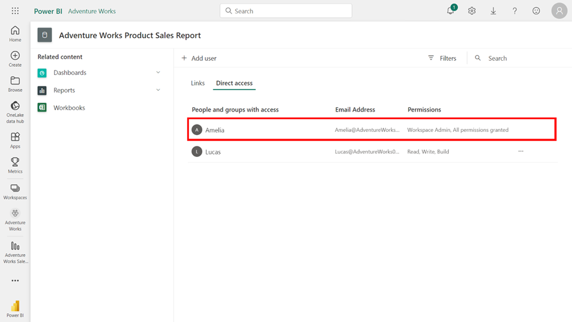

**Conclusion**

As a data analyst, you must use permissions responsibly. Ensure that you understand the purpose and implications of each permission level. With this knowledge, you can assign people the permissions they require to carry out and complete their tasks without risking the integrity of your datasets.